**METAL DETECTOR**

**A**

**Mini Project Report**

**Submitted to**

**CHHATTISGARH SWAMI VIVEKANAND TECHNICAL UNIVERSITY**

**BHILAI (C.G.), INDIA**

***In partial fulfilment of B.Tech IV Semester***

**in**

**Electronics & Telecommunication Engineering**

**by**

**MANSI VERMA(BK3535), PARAG DEWANGAN, RAJNISH GOSWAMI & VRUSHALI ASODKAR(BK3565)**

**Under the Guidance of**

**K. UMA**

**Assistant Professor**

**Dept. of Elect. & Telecomm. Engg.**

**DEPARTMENT OF ELECTRONICS & TELECOMMUNICATION ENGINEERING**

**BHILAI INSTITUTE OF TECHNOLOGY, BHILAI HOUSE, DURG (C.G.) -491001,**

**INDIA**

**SESSION 2021-2022**



**CERTIFICATE BY THE SUPERVISOR**

This is to certify that the report of the Project submitted is an outcome of the project work entitled ***“METAL DETECTOR”***, carried out by following students under my guidance and supervision during, ***B.Tech IVth Sem*** of ***Electronics and Telecommunication Engineering*** of Chhattisgarh Swami Vivekanand Technical University, Bhilai (C.G.), India.

To the best of my knowledge and the Report

1. Embodies the work of the candidate him/herself,
2. Has duly been completed,
3. Is up to the desired standard for the purpose of which is submitted.

Name of the students are:

***Mansi Verma, Roll No.: 300102820034*** & ***Enrl No.: BK3535.*** ………Sign…..

***Parag Dewangan, Roll No.: 300102820041*** & ***Enrl No.: BK35.*** …… .Sign…..

***Rajnish Goswami, Roll No.: 300102820076*** & ***Enrl No.: BK3535.*** ………Sign…..

***Vrushali Asodkar, Roll No.: 300102820064*** & ***Enrl No.: BK3565.*** ………Sign…..

Name of Guide-

K. Uma

Professor

Department of Electronics

& Telecommunication Engg.

BIT, Durg

Name of Project Incharge-

Prof. Dr. Arun Kumar

Professor

Department of Electronics

& Telecommunication Engg.

BIT, Durg

The project work as mentioned above is hereby being recommended and forwarded for examination and evaluation.

Signature of

Head of the Department

With Seal

**TABLE OF CONTENTS**

**CHAPTER TITLE**  **PAGE NO.**

1. **INTRODUCTION 1**

* Brief introduction
* Aim & objectives of the project 2

1. **METHODOLOGY & HARDWARE IMPLEMENTATION**

* Introduction 3
* Block diagram 4
* Hardware Components 5
* Project code 6

**4 RESULTS 7**

* Picture of hardware 8
* Discussion 9

**5 CONCLUSION AND APPLICATION 10**

**REFERENCES 11**

**(at least five reference)**

**CHAPTER 1: INTRODUCTION**

A **metal detector** is an [instrument](https://en.wikipedia.org/wiki/Electronic_instrumentation) that detects the presence of [metal](https://en.wikipedia.org/wiki/Metal) nearby. Metal detector is a very common device that is used for checking persons, luggage or bags in shopping malls, hotels, cinema halls, etc. to ensure that person is not carrying any metals or illegal things like guns, bombs etc. Metal Detectors detect the presence of metals.

There are different types of metal detectors like hand held metal detectors, walk through metal detectors and ground search metal detectors.

The simplest form of a metal detector consists of an [oscillator](https://en.wikipedia.org/wiki/Electronic_oscillator) producing an [alternating current](https://en.wikipedia.org/wiki/Alternating_current) that passes through a coil producing an alternating [magnetic field](https://en.wikipedia.org/wiki/Magnetic_field). If a piece of electrically conductive metal is close to the coil, [eddy currents](https://en.wikipedia.org/wiki/Eddy_currents) will be induced ([inductive sensor](https://en.wikipedia.org/wiki/Inductive_sensor)) in the metal, and this produces a magnetic field of its own. If another coil is used to measure the magnetic field (acting as a [magnetometer](https://en.wikipedia.org/wiki/Magnetometer)), the change in the magnetic field due to the metallic object can be detected.

**CHAPTER 2 - HARDWARE IMPLEMENTATION**

First the components were gathered and mounted on a zero board. Connections are done according to the circuit diagram.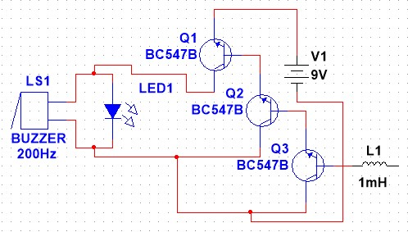The parts and soldered using a soldering and a 9V DC battery is used to power the circuit. When the power is turned on, and any metal is detected, the LED turns on and the buzzer makes a sound.

**CHAPTER 3 – RESULTS**

RESULTS-

In this chapter, we will discuss the results of our metal detector.

The following figure shows the result that is collected from our Metal detector.

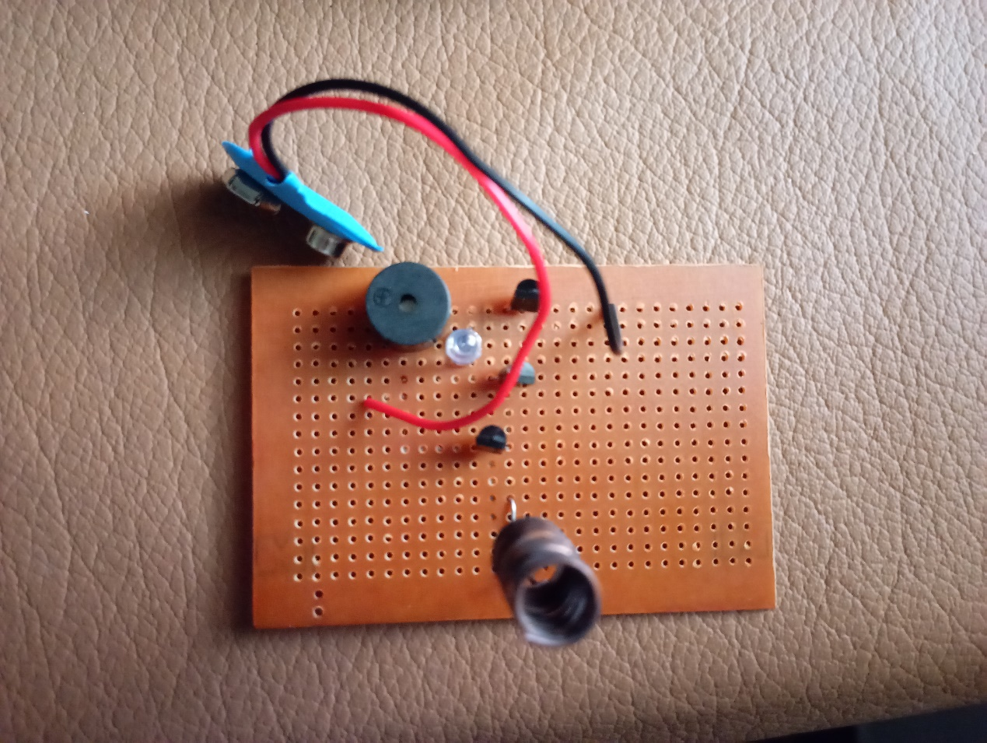FIG 12- RESULT

# DISCUSSION-

The metal detector is a simple device that works on two principles -

1. Faraday’s Law of Electromagnetic Induction – Whenever there is a change in the magnetic flux associated with a coil and emf is induced in the coil and vice versa. Because of this magnetic flux, current is flowing through the circuit.
2. Lenz’s Law – The emf produced in a circuit opposes its cause.

When a metal is brought near a current- carrying coil (which has a magnetic field established), the emf linked with the coil changed. This produces a current in the field in the opposite direction. Initially, the speaker was receiving a voltage of around 1.8V. When a metal comes in contact, the voltage increases to 2.5V and the buzzer makes a noise.

Almost all of the metal detectors work the same.

**CHAPTER 4 - CONCLUSION AND APPLICATION**

# CONCLUSION

1. This project works to detect metals using a very simple circuit and a smaller number of components.
2. Due to its small size, it can only detect metals when they are very closed to it.
3. This problem can be corrected by using a coil of more turns and bigger radius.

# Application-

* Metal detectors are used in airports to screen passengers, checking bags in public places and in public events.
* Since it is a simple project, we can use this in our home to scan for nails, metal scraps etc. which are not easily spotted by naked eye.
* They are used in food processing industries to detect fragments of metal so as to avoid food contamination.
* Archaeological use in antique detection.

**REFERENCES**

[1]<https://www.electronicshub.org/metal-detector-circuit/>

[2]<https://www.google.co.in/>

[3]<https://www.youtube.com/watch?v=WMVfWru3bIA>

[4]<https://electronics.howstuffworks.com/gadgets/other-gadgets/metal-detector.htm>

[5]<https://www.sciencedirect.com/topics/computer-science/metal-detector>